**WEBSITE URL:** [**https://cofftasticstore.000webhostapp.com/**](https://cofftasticstore.000webhostapp.com/)

**GITHUB URL: https://github.com/chrisjblu/CofftasticShop**

Participants:

**Jegan Francis Mendy x18131212**

**Christopher Angbalu x17366481**

**Abraham Marcus Alabi x17342373**

Christopher Angbalu – PHP, SQL, HTML, CSS, SECRUITY

The bases for our website is a coffee shop. I used the method of crude to create a responsive registration and login system. First page I created was the registration page, the first step was to implement and position the DIVS on the registration.php page. Once the DIVS are done I added the cofftastic logo. Next step was to create a form which consisted of the username, password and confirm password. To make the password and confirm password to work I used php if statements. Once that was done, we used java Script alert box to output user has successfully registered.

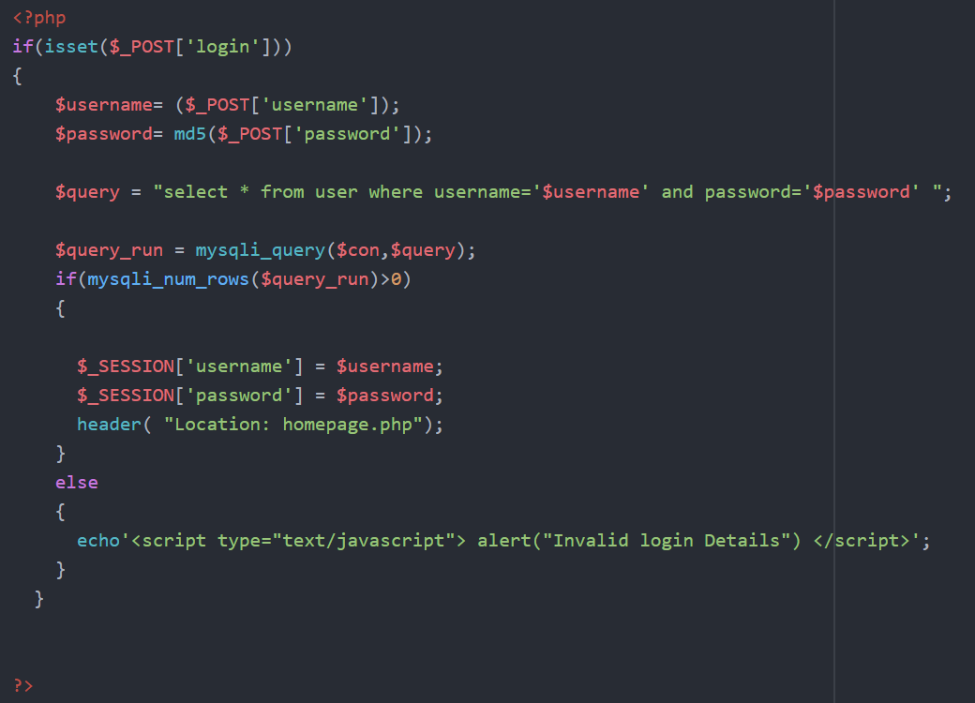

For the login i created the user and password text fields, the information entered in must be correct or you will not be able to log in. When successful you are redirected. On the homepage you are greeted by the name your registered.

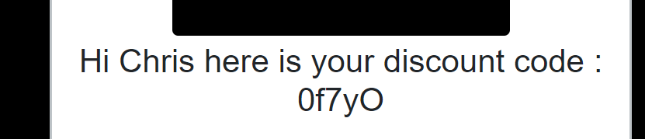

This was implemented by echoing the session username.



Under the discount section is a logout button, once pressed you are logged out you are redirected to the index page and the session is destroyed.

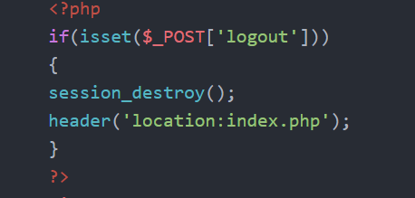

The delete section has a text field which allows you to type in your username, once this is done you can click the delete account button which will delete your account from the database.

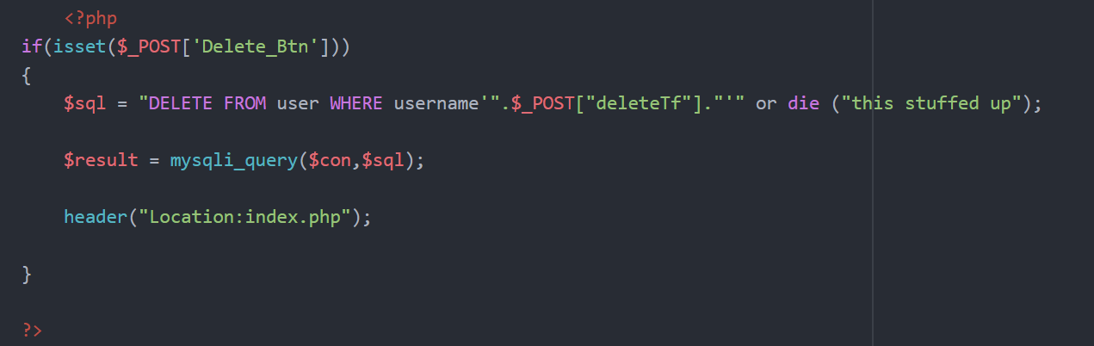

Click the Change password button to be redirected to the page you must enter your old password and your new password. Once this is complete your password will change with in the database.

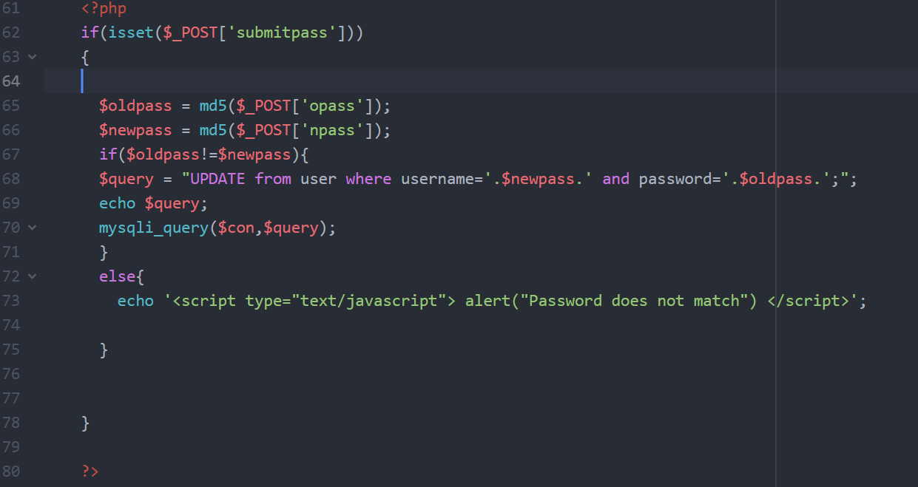

For security purposes I encrypted passswords using MD5.

Abraham Marcus Alabi x17342373

In the web Application project, my job was to create the side-nav bar using bootstrap & creating the discount code. For me to complete my task, I went to w3schols & researched about sidenav bars & the different types. I discussed with my fellow colleges on which side-nav I had chosen to implement. We decided to implement a video as our homepage, so we got a free coffee video from an online source. I found out that Google on a recent update removed the option to allow videos to play in the background with sound. You must mute the video in the background or it will not work. 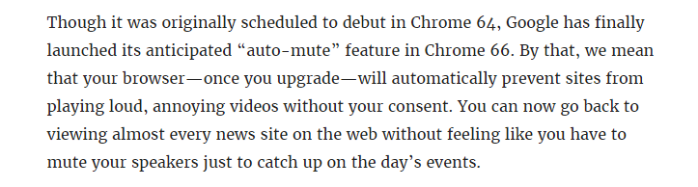

as I implemented the video errors occurred. On the pc I used to create the code, the video ran fine until I went on a different pc monitor, the video wouldn’t fit on the screen. I tried on a different monitors & the same errors occurred. It was only until I included bootstrap was when the video started functioning right. After I began researching on how to implement a side-nav bar with bootstrap as I was unfamiliar with it.

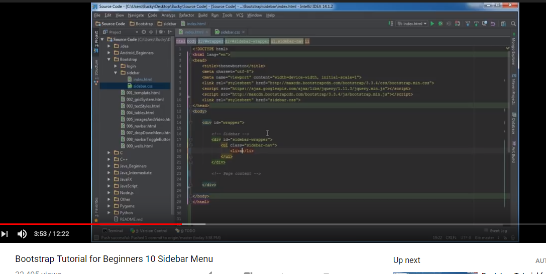

The next step was implementing the navbar on the video. By using rows & col, I was able to accomplish it.

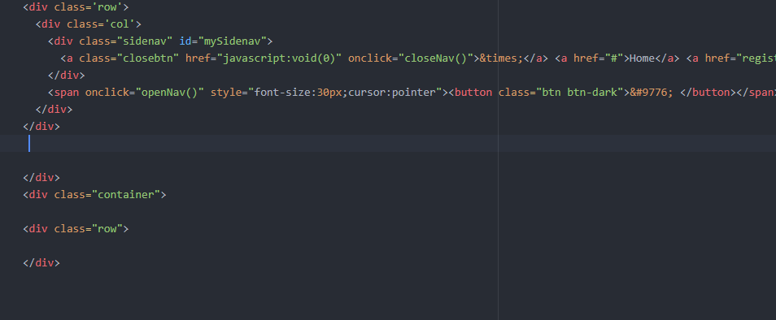

The job I had to do was to create discount code. they was problem displaying the code, I put in was on the console log code which was displaying in the console log. I fixed the problem by adding the code “document. Write(text);”

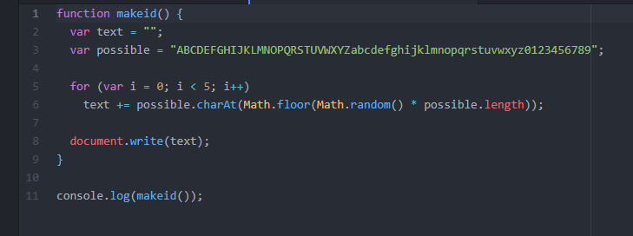

Our Location & Contacts Page

By:X18131212

This page was created with the use of the **Mapbox API** specifically the **store locator** using**Mapbox GL JS.**With the aid of the store locator end-users will be able to browse through a catalog of locations from a sidebar and select a specific store to see more information. They also have the option of selecting a marker on the map which will highlight the selected store on the sidebar. (Mapbox, 2018)

REFERENCES

Lifehacker.com. (2018). [online] Available at: https://lifehacker.com/mute-most-autoplay-videos-with-the-latest-chrome-update-1825354497 [Accessed 10 Dec. 2018].

W3schools.com. (2018). *Bootstrap Navigation Bar*. [online] Available at: https://www.w3schools.com/bootstrap/bootstrap_navbar.asp [Accessed 10 Dec. 2018].

YouTube. (2018). *Bootstrap Tutorial for Beginners 10 Sidebar Menu*. [online] Available at: https://www.youtube.com/watch?v=ktGbK9wUaC0 [Accessed 10 Dec. 2018].

Mapbox. (2018). *Mapbox*. [online] Available at: https://www.mapbox.com/ [Accessed 6 Dec. 2018].

CafÃ©, C. (2018). *Free stock video of café, coffee machine, cup*. [online] Videos.pexels.com. Available at: https://videos.pexels.com/videos/coffee-machine-in-cafa-852035 [Accessed 10 Dec. 2018].